1) a) All my work was done by hand then copied to a digital format to ease reading when possible

Newton method:

|  |  |  |  |
| --- | --- | --- | --- |
| Xn | F(Xn) | F'(Xn) | |Xn-Xn-1| |
| 1 | -1 | 3 | N/A |
| 1.333333333 | -0.182605044 | 2 | 0.333333333 |
| 1.424635855 | -0.008970892 | 1.807735033 | 0.091302522 |
| 1.429598359 | -2.42112E-05 | 1.797988662 | 0.004962504 |
| 1.429611825 | -2E-10 | 1.797962308 | 1.34657E-05 |
| 1.429611825 | 0 | 1.797962308 | 1E-10 |
| 1.429611825 | 0 | 1.797962308 | 0 |

Secant method:

|  |  |  |  |
| --- | --- | --- | --- |
| Xn | F(Xn) | F'(Xn) | |Xn-Xn-1| |
| 1 | -1 | N/A | N/A |
| 2 | 0.772588722 | 1.772588722 | 1 |
| 1.564146656 | 0.225214974 | 1.255866808 | 0.435853344 |
| 1.384816354 | -0.082546216 | 1.716169476 | 0.179330302 |
| 1.432915459 | 0.005929147 | 1.839438849 | 0.048099105 |
| 1.429692114 | 0.000144351 | 1.794655983 | 0.003223345 |
| 1.42961168 | -2.596E-07 | 1.797883883 | 8.04336E-05 |
| 1.429611825 | 0 | 1.797962449 | 1.444E-07 |

Here are the equations that I used for my B and C parts

b) I used En=Xn – r to calculate the error estimate. since I don’t actually know the correct exact root I used the last iteration calculated instead of r in my code.

For the newton method:

|  |  |
| --- | --- |
| Xn | Error estimate |
| 1 | 0.429612 |
| 1.333333333 | 0.096278 |
| 1.424635855 | 0.004976 |
| 1.429598359 | 1.35E-05 |
| 1.429611825 | 9.87E-11 |
| 1.429611825 | 0 |
| 1.429611825 | Value used as root, thus 0 |

For the secant method:

|  |  |
| --- | --- |
| Xn | Error estimate |
| 1 | 0.429612 |
| 2 | 0.570388 |
| 1.564146656 | 0.134535 |
| 1.384816354 | 0.044795 |
| 1.432915459 | 0.003304 |
| 1.429692114 | 8.03E-05 |
| 1.42961168 | 1.44E-07 |
| 1.429611825 | Value used as root, thus 0 |

c) we know the error estimate is En=Xn – r from part b, thus by using the newton formula

Xn+1 = Xn - f(Xn)/f'(xn)

En+1 + r= En + r - f(Xn)/f'(xn)

En+1 = En- f(Xn)/f'(xn)

If what is meant by the question is to find the relative error however, then the answer would be:  
|Xn+1 - Xn|/ |Xn+1|

d) 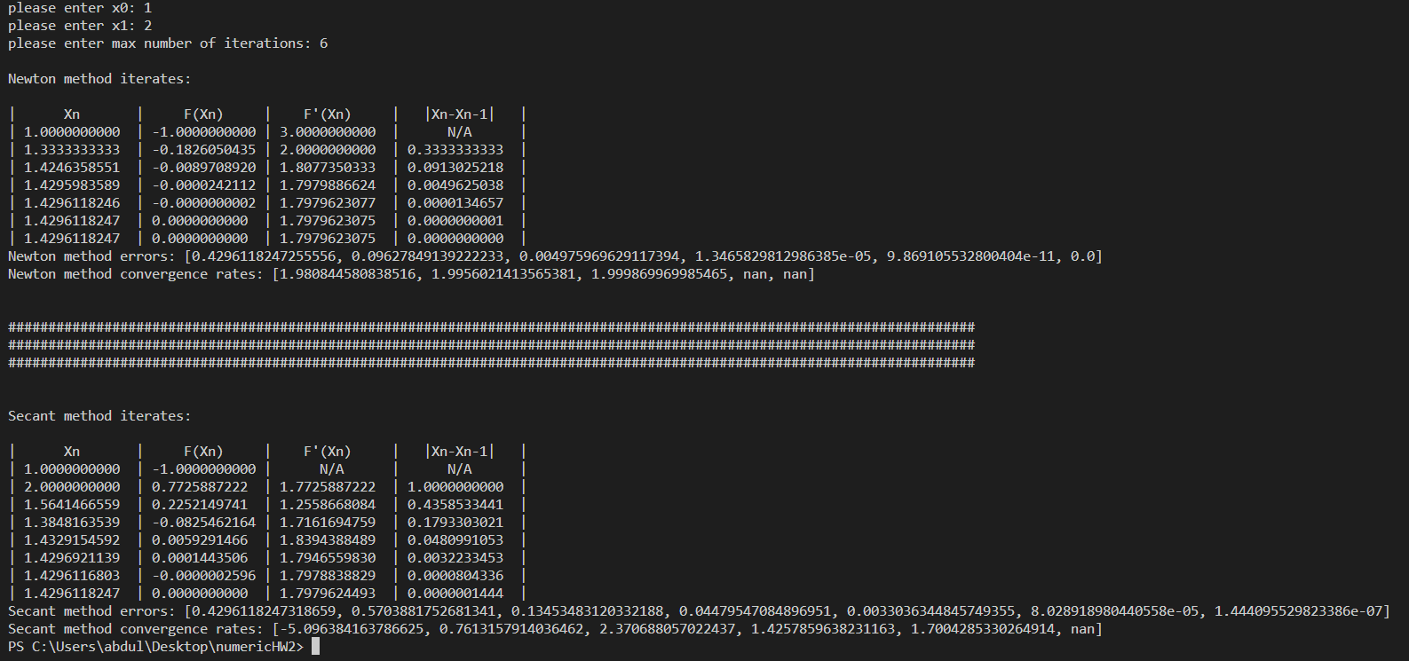

for my convergence calculation, since it was not explained in class I did some research and discussed the question with some other students, I decided to use this equation: 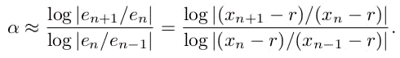

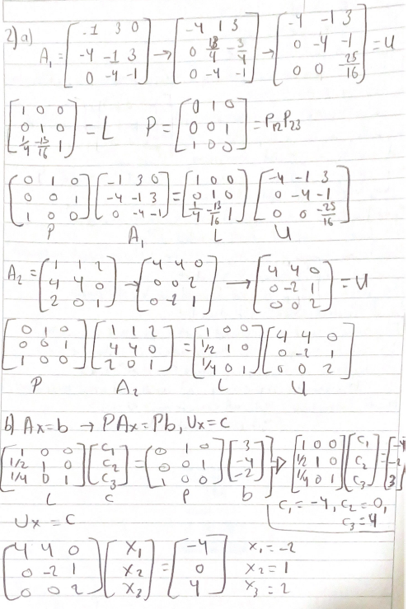2)

3)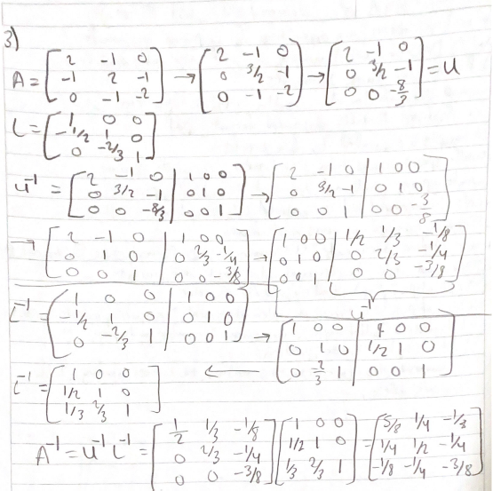

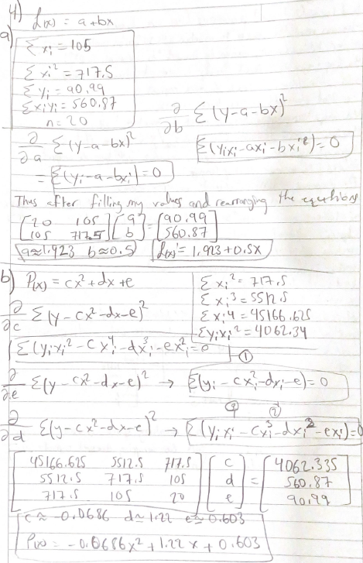4)

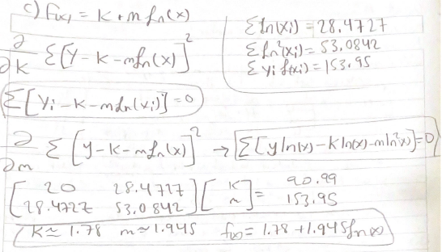

4)d)